* IAM Access
* Managed/Unmanaged
  + OS installation/management
  + Database installation/management
  + Backups ( Maintains 7 Backups for each instance for cloud sql)
  + Availability:
    - Failover – If e.g. database stops working, it will be replicated over another zone/region
    - Read Replicas
  + Scaling – Disk Space (Vertical(read and write) for cloud sql, >100gb ram)
  + Monitoring, (cloud sql supports 3 read replicas(Horizontal Scaling), automatic replica)
  + Authorize network connections
* Schema Design
* Configuration of each storage/tool
* Ops/ No-ops – Whether we have to provision cluster or instances
* Cost

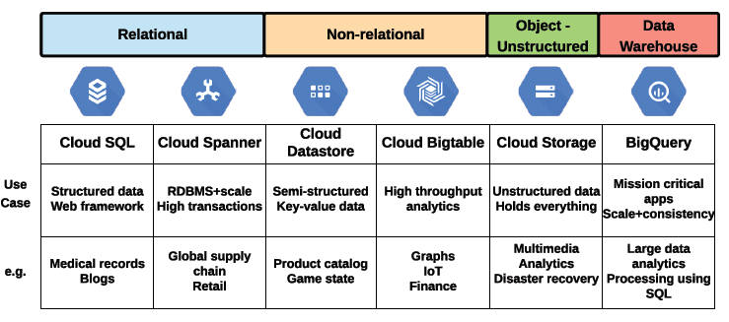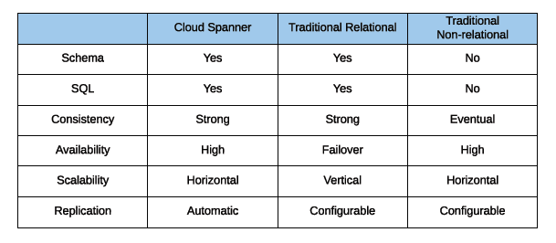

# 1. Big Query

## 1.1 Specifications

* Data warehouse does not fall under relational or non-relational.
* Fully Managed Data Warehouse
* No-ops (Serverless)
* Scaling - Auto Scaling (Horizontal and Vertical)
* Availability (High) – Multi Regional, Regional
* Replicated and Durable
* Backup – Big query automatically takes continuous snapshots of tables.
* SQL – Yes
* Batch and Streaming Loads
* Maxes out a 100 000 rows/table/second

## 1.2 How it works

* Columnar **Datastore**
* Records are separated into column values
* Each value stored on a separate **volume**
* A **traditional database stores whole record** on **one volume**
* Extremely fast read performance, but poor write (update)
* **Not Transactional** – because it **does not update records**

## 1.3 Structure

* Project contains Datasets
* Datasets contains multiple tables/views
* 1000 Tables per Dataset
* Job – Long running action query

Storing your large reporting tables as STRUCTs (pre-joined "tables") and ARRAYs (deep granularity) allows you to:

* gain significant performance advantages by avoiding 32 table JOINs
* get granular data from ARRAYs when you need it but not be punished if you dont (BigQuery stores each column individually on disk)
* have all the business context in one table as opposed to worrying about JOIN keys and which tables have the data you need
* Example of Struct “totals” schema type **RECORD**, e.g. “totals.visits, totals.hits”, instead of splitting into separate tables
* Example of Arrays schema mode **REPEATED**

# 2. Dataproc (Same as Cloud Dataflow)

## 2.1 Specifications

* Managed Hadoop and Spark Clusters
* Scaling – Configurable (not auto scaling)

# 3. Cloud Dataflow

## 3.1 Specifications

* Stream and Batch processing
* No-ops
* Scaling – Auto scaling
* Availability – Pipelines are only regional based

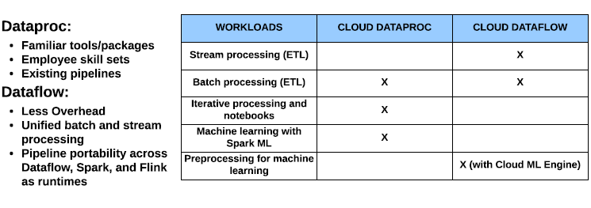

## 3.2 How it works

* Pub/sub does not care about the order of data, this is done in cloud dataflow.
* For ordering, cloud dataflow uses **windows, watermarks and triggers**.
* Windows – Logically divides element groups by timespan
* Watermarks – Timestamp,
  + Event time – when data was generated
  + Processing time – when data processed anywhere in the processing pipeline
  + Can use Pub/Sub provided watermark or source-generated
* Trigger – Determine when results in window are emitted (submit as complete)

# 4. Pub/Sub

## 4.1 Specifications

* Pub/Sub is a global scale messaging buffer/coupler
* Availability(High) – Global availability
* Scalability – Auto scaling
* No – ops

## 4.2 How it works

* Uses the following:
  + Topics
  + Publishers
  + Subscribers
  + Messages
  + Message Store
* Can have a Stream subscription/ Batch subscription, remember subscription is from the receiver end. Stream is with the push, batch is with the pull.

# 5. Cloud Storage

* Replication – Automatic across multi regions, for single region, replication is across zones. If the files are corrupted it will be restored automatically from these replications



* 3 Types: Standard(normal), nearline(30 days), coldline(90 days), days are minimum storage duration. So if it is accessed once a year/quarter, move object from standard to coldline storage.
* IAM controls the policy and we have the access control list which is in the IAM role.
* Cloud IAM provide Project Roles and Bucket Roles.
* Access list in **bucket role** is Reader, Writer, Owner, Set ACL Policy
* **Project Role** allows us to create **IAM Policy, create and delete buckets**
* Custom Roles are also available
* Project Roles access list is Viewer, Editor, Owner **roles** that gives access to a group of internal members of bucket roles.
* When creating a bucket, you offered the option of disabling access lists and only using Cloud IAM
* An example of using IAM, we use cloud IAM to give a reader access to a bucket, we also give writer access, but to a specific object in that bucket through access control list
* You can also give these permissions to **service accounts** as well as **applications**

# 6. Cloud Dataflow

* The below is an example in python code

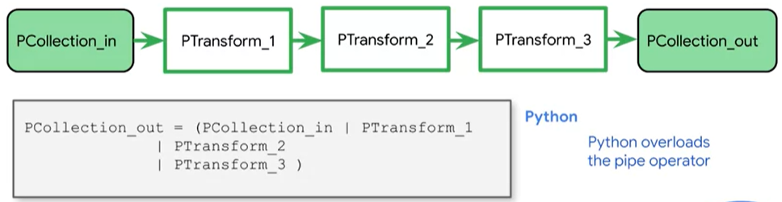

* The below is an example of branching

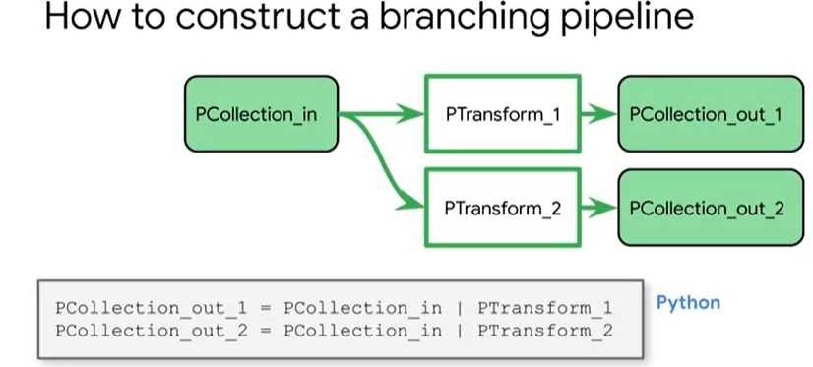

* In the below we already have a PCollection i.e. p and we are applying a bunch of transforms resulting in an output PCollection

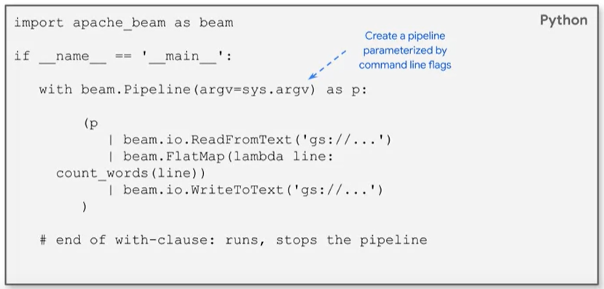

* We get the input PCollection from a **source**
* We write out the output PCollection to a **sink**
* The first line we create a PCollection by passing it a text file from google cloud storage i.e. p|beam.io.ReadFromText(‘gs:// …’)
* Next we create a PTransform with the 2nd line beam.FlatMap(lambda line: count_words(line))
* **Because the pipeline is created with a “with” clause it is not a streaming pipeline**
* The end of the with-clause automatically stops the pipeline since it is not a streaming pipeline
* Now that we have created the pipeline, we now need to run the pipeline shown below

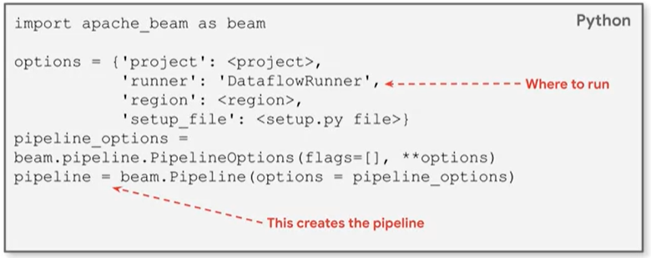

* By setting the ‘runner’ to ‘DataflowRunner’, this executes the pipeline in cloud dataflow
* You will create command line parameters to automatically switch between running it locally and cloud dataflow below, by passing in the relevant parameters

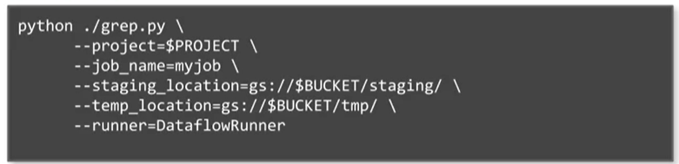

### Passing in Data from Different Sources

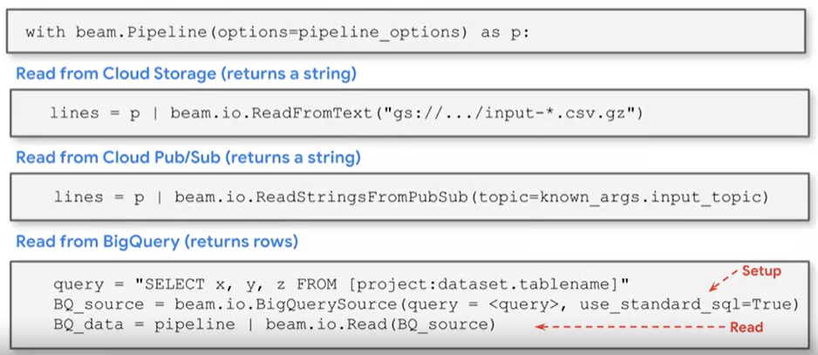

* Writing to sinks such as Big Query shown below

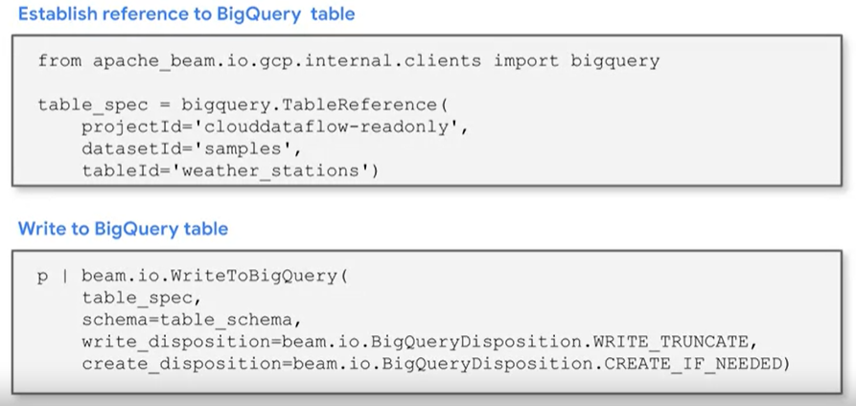

* We can also create a PCollection **in memory** without reading from a Data Source show below

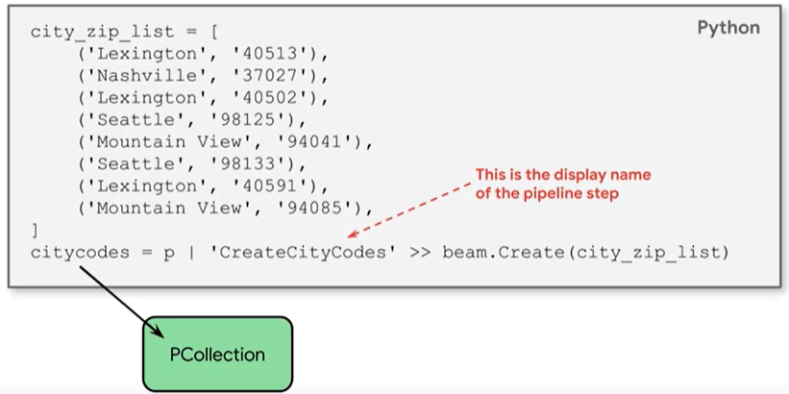

* Notice the “>>” operation which is used when we are creating a name for the pipeline step
* In all of the examples above we didn’t show how the lambda functions are written, we show this in the below example of a PTransform

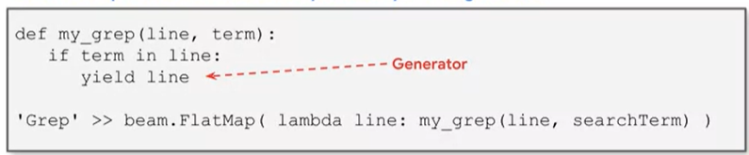

* We notice in the code above, the function has a **generator** which returns the next instance of the line. We use **yield** to return the next instance of the line
* **ParDo or Parallel Do is a common intermediate step in the pipeline**
* **ParDo implements parallel processing**
* **Examples of how ParDo is used**

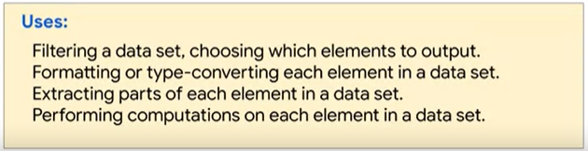

* An example of using ParDo below

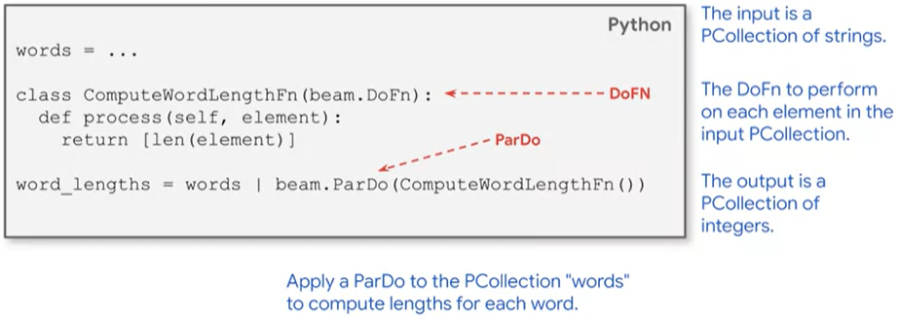

* When using ParDo, we have to provide user code in the form of a **DoFn object**
* A DoFn is a beam sdk class that defines a distributed processing function
* The DoFn must be fully serializable, item potent and thread safe
* Transformations will always work on one element at a time
* ParDo can return multiple variables shown below

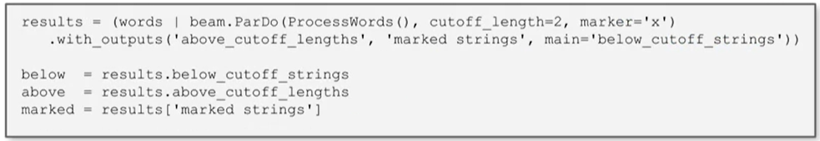

* Notice the .with_outputs to return multiple variables which obviously has to be returned in the function ProcessWords(), this function will have to return multiple variables for the ParDo to output multiple variables

### Combine and GroupBy

* After the Map Phase is the Shuffle(Not Shuffling) Phase
* The shuffle phase is where you group together like keys shown below
* As you can see below, the Map phase selects the two fields e.g. on the left diagram Lexington occurs 3 times before we group by the key Lexington. Notice even though there is a **“,”** between the fields we still use the first element as a key
* This works on key-value pairs, or 2 element tuples like the example below
* On the right diagram, we are just grouping by our key in the left diagram, since Lexington occurs 3 times, we will have 3 of it’s values.

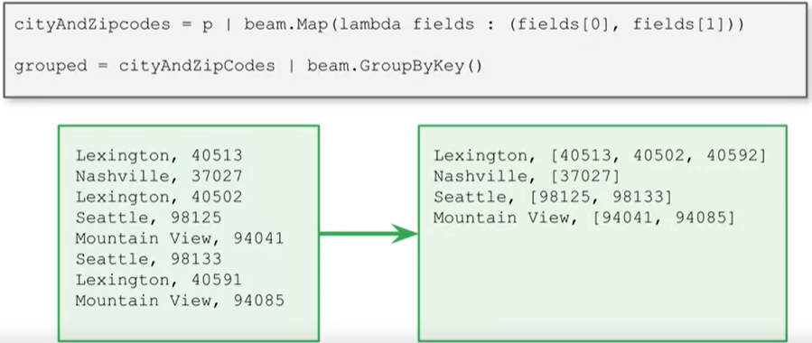

* We have to be aware of skew data when we are doing this because it can be inefficient, skew data means, that there is more of one key compared to the others. Example say Lexington had 1000 values and Seattle only has 2 values, this will be skewed data.
* In the below example is an example of 2 key groups x and y
* Grouping by the X group has 1 Million items
* Grouping by the Y group has 1000 items
* Since they are executed on different workers, the Y group worker is left idle because the X group worker is taking long to complete which is inefficient

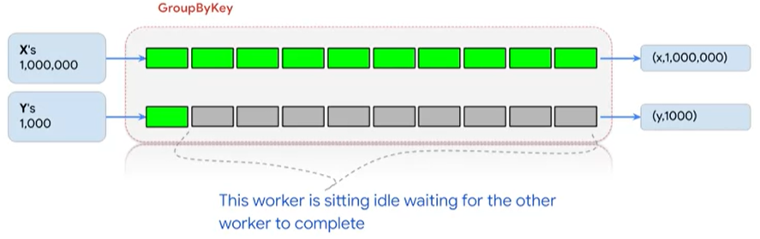

* Dataflow allows balancing of data removing this skewness
* We can do this by aggreagating stpes into subsequent steps avoiding grouping or pushing grouping to the end of the Data Pipeline
* **CoGroupByKey** is similar to groupby key, it groups results across several PCollections by key shown below
* **CoGroupByKey performs a join on key-values with the same key**. In the example below, the key for our “**orders**” table is order_id, the key for our “**shipments**” table is also order_id.
* **So a join can be performed on the order_id key**

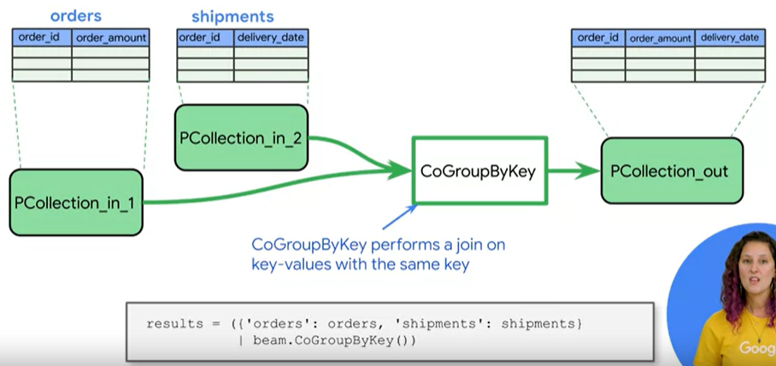

* Next we can move to the reduce phase, e.g. summing up all the items for a specific key.

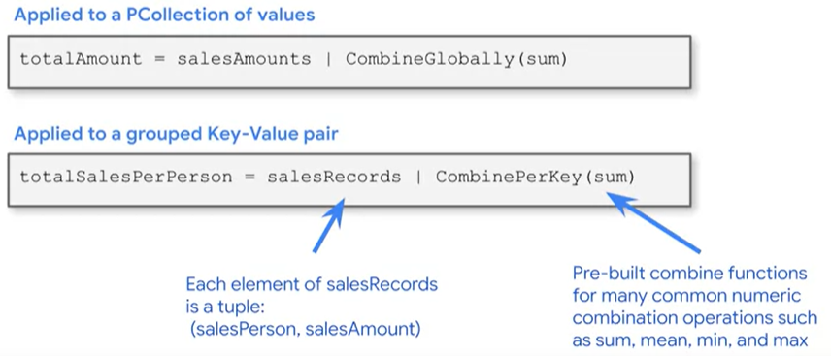

* Above, if salesAmounts is a collection of amounts, then CombineGlobally(sum) reduces a PCollection to a single value.
* CombinePerKey(sum) is similar to GroupByKey but combines the values for each key
* Combine(allows dataflow to distribute a key to multiple workers) is faster than GroupBy(can only use one worker per key)

### More Beam Operations

* Flatten, just like flatmap(applies function and then flattens), but flatten just combines all of the PCollections show below.

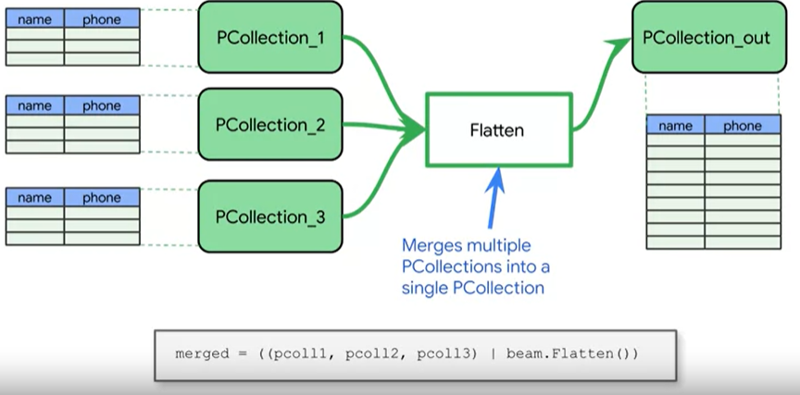

* Partition is also a beam transform

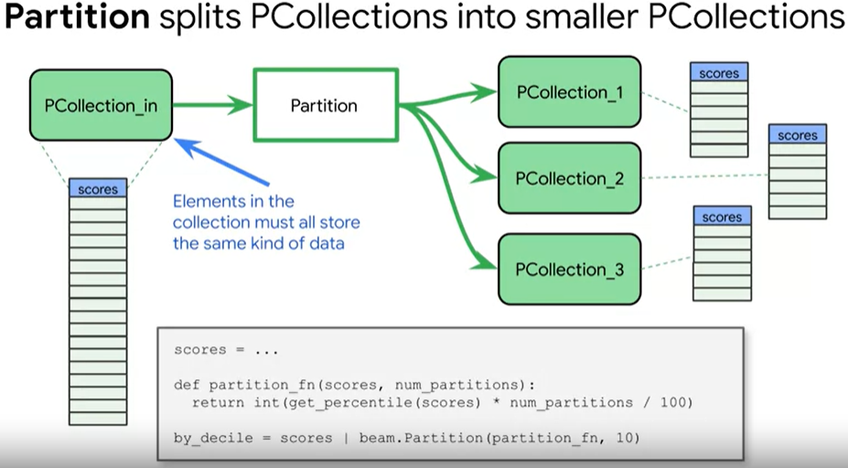

### Side Inputs

* You can provide additional inputs to a ParDo transform in the form of side inputs
* A side input is an additional input that your do function can access each time it processes an element in the PCollection
* When you specify a side input, you create a view of some other data that can be read from within the ParDo transforms Do function while processing each element
* Side inputs are useful when your ParDo needs to inject additional data when processing additional elements in the input PCollection, but the additional data needs to be determined at runtime and not hard coded.

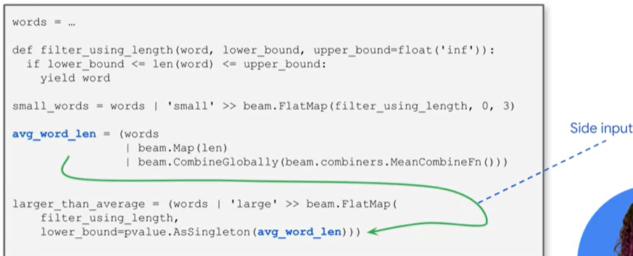

### Cloud Dataflow from the Streaming Course

* There can be network delays with data arriving from pub/sub, so the data will be out of order. However when a sensor reading is taken it will have a timestamp, we can use this timestamp to re-order the messages.
* Here is an example of code below to create a window using the timestamp

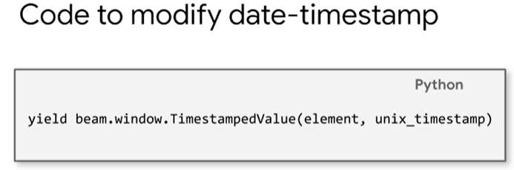

* There are 3 kinds of windows shown below
* A fixed window is a window such as hourly, daily, weekly, monthly, etc.
* Sliding windows can be overlapping such as a running average. An example of a sliding window is given 5 minutes worth of data computed every 30 minutes. This means that all the 5 minutes worth of data piles up and is computed every 30 minutes
* Sessions windows are defined by minimum gap duration and the timing is triggered by another element. Session windows are for situations where the communication is bursty. This might correspond to a web session, e.g. a user comes in and uses 4 to 5 pages and then leaves. We can capture this as a session window. You can have a timeout period and it will flush that window at that timeout period

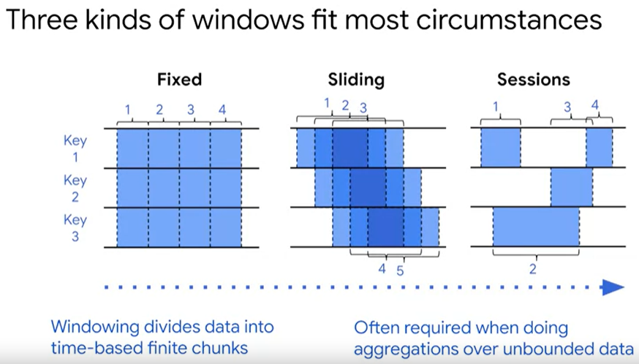

* Code is shown below for creating different types of windows. Batch data can also be windowed using the timestamp from the meta data

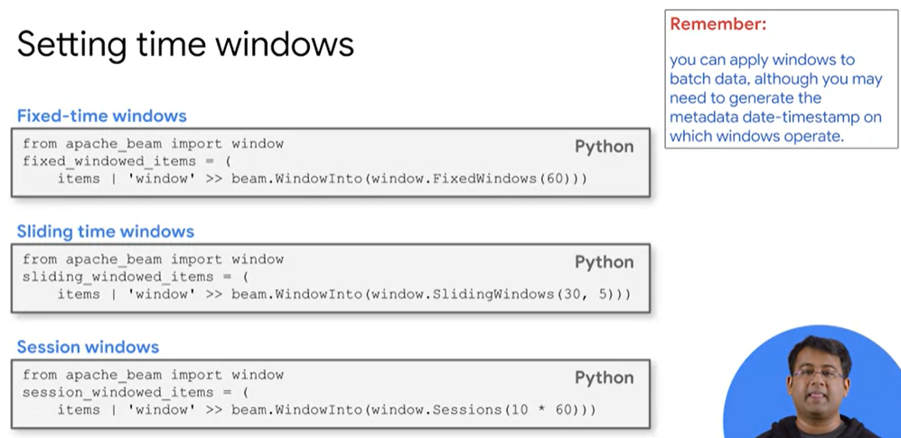

* First block of code creates windows starting every 60 seconds
* The second block, the first argument 30 refers to the length of the window which is 30 seconds. The second argument 5 refers to how often new windows open which is 5 seconds. So in simple terms what this means is that every 5 seconds, we will have a new window length of 30 seconds
* The third block has a window that timesout after 10 minutes i.e. 10 * 60seconds
* The below diagram is an example of how to deal with latency

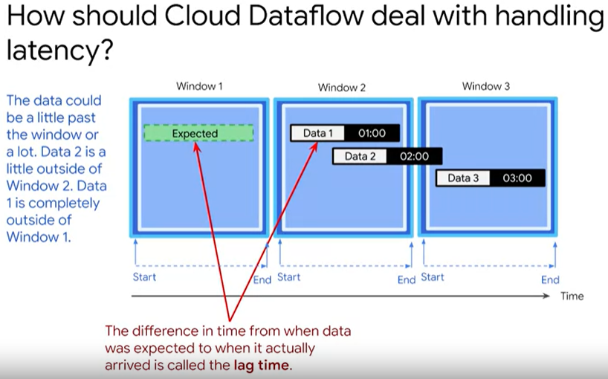

* We can see above that Data 1 arrived late in Window 2 and not in Window 1. Data 2 suppose to arrive at the beginning of Window 2, but arrived between Window 2 and Window 3.
* The system should know the difference between expected arrival time and actual arrival time known as lag time
* Dataflow can keep track of this lag time using a technique called watermark
* So dataflow continuously computes the watermark which is how far behind is the data
* Dataflow is going to wait for the watermark it has computed until it is elapsed
* Example if it is running a system with a lag of 4 seconds, then it will wait 4 seconds before it flushes the window because it believes that all the data should have arrived for that time period
* Say now that the data arrive after the window has closed even with our lag(extra time), so by default the data gets discarded, but we can set it to reprocess the window based on the late arrivals
* Data may arrive late in the system and we need to consider it in the aggregations
* Using Triggers:
  + **AfterWatermark**(Event Type Trigger) - we have Event Time triggers which operates with date timestamp associated with each element. During the watermark passing the aggregation steps will be performed i.e. aggregations(transformations) will be performed for that window. After the watermark has been passed the Default Event Time Trigger will be activated i.e. omit the results of the aggregation, and discard any data that arrives late
  + **AfterProcessingTime**(Processing Type Trigger) – operates on the time at which the elements are processed at some point in the pipeline determined by a system clock. Can set this type of trigger on unbounded data contained in a global window. E.g. emitting(after completion) data every 30 seconds, the data will never end, the window never closes, but interim results are emitted(aggregations performed) every 30 seconds by the trigger
  + **AfterCount**(Data Driven Trigger) – is associated with the condition of data contained in the element itself. This counts each element that has been processed in the window. You could set a count to 15 and after 15 elements have been processed, then the aggregations will be performed
  + **Composite Triggers combines the above 3 triggers** – Example if 14 elements were processed and the 15 element did not arrive, the 14 elements would sit in the window forever, in this case you can combine it with an even time trigger to ensure that the last 14 elements were emitted.
* Examples shown below, don’t worry too much for not understanding as long as I understand the basic concept

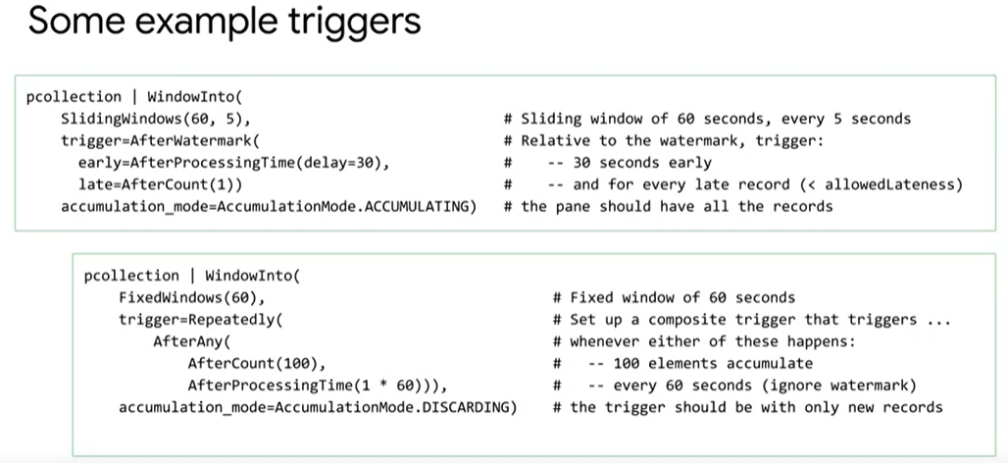

## Streaming Data Course

* Challenges with streaming data

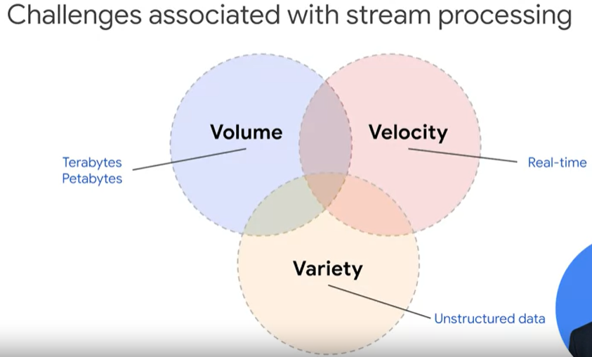

* Solution shown below to handle these challenges
* For Velocity we will look at tools to handle the streaming processing shown in the diagram below

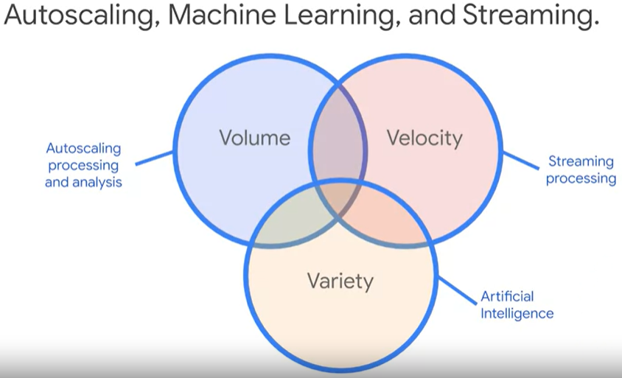

* Tools shown below for solution to the above

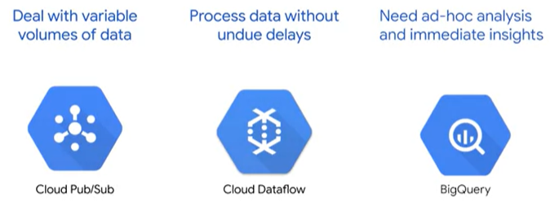

* Entire streaming process shown below
* Our source data generates events, discussed events in this document with cloud functions.
* Next Pub/Sub handles these events
* Cloud Dataflow performs transformations and writes to Big Query/Big Table or Cloud Dataflow can be used to train models in Real Time using AI Platform/dataflow can just send requests to the model for predictions.
* Dataflow can again be used in Batch Mode for things like Backfilling, so you can reconstruct the historical events that happened or maybe you need to reprocess the data differently to look at other dimensions

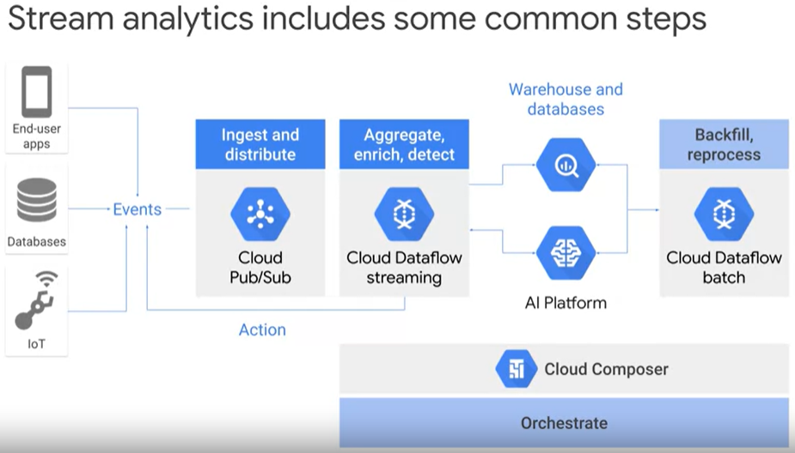

* Let’s take an example for Cloud Pub/Sub, on Black Friday the volumes are super high, so Pub/Sub has a Buffer capability that can be used so that it accommodates for the speed at which systems can process this data. If systems can’t handle the data fast enough, it will just make use of the Buffer capability
* A topic can have multiple subscriptions, but a subscription can only be subscribed to a single topic
* A detailed diagram for Pub/Sub is shown below
* In the first block highlighted below, we just have a single publisher which publishes a message to a topic. The different colour blocks for the messages means that there are different messages being sent.
* In the second block next to the first highlighted block, is fan-in or load balancing. Multiple publishers can publish to the same topic and multiple subscribers can pull from the same subscription leveraging parallel processing. So there are 2 different publishers sending 3 different messages to the same topic, which means that the subscription will get 3 different messages from the topic
* The third block is fan-out, where you have many use cases for the same piece of data and all data is sent to many different subscribers, as you can see we have 2 different subscriptions, so each subscription will get both the messages

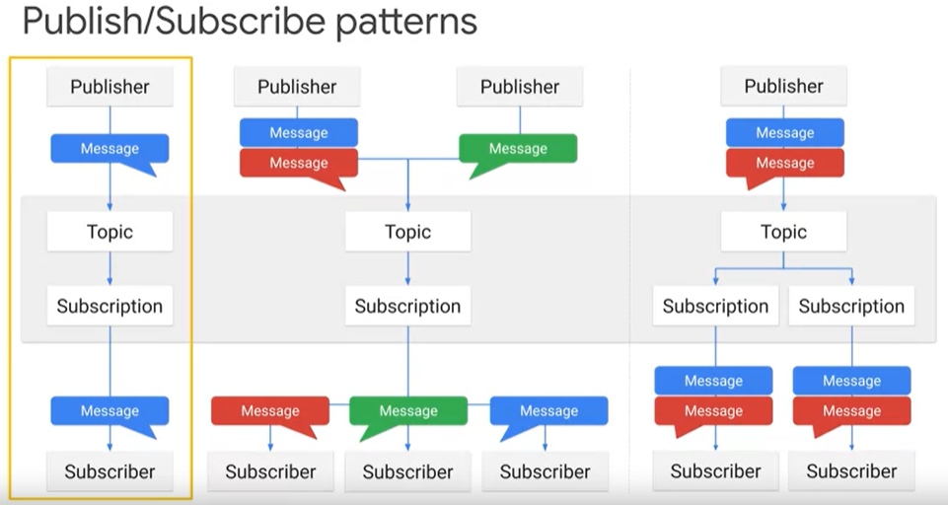

* We have to types of models for subscribers i.e. Pull and Push, below we show the pull model

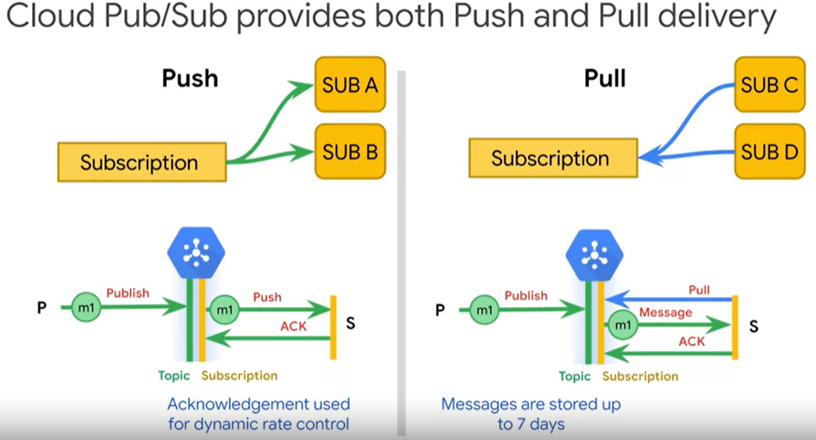

* Initially the call is made to the subscriber
* It pulls the messages, it gets the messages back
* Next it separately acknowledges that message
* In the push model, Pub/Sub initiates requests to your subscriber application to deliver messages. The Cloud Pub/Sub server sends each message as an HTTPS request to the subscriber application at a preconfigured endpoint. In the push model you just respond with status 200 Okay for the HTTP call and this tells pub/sub that the message delivery was successful
* Push delivery is ideal when **multiple topics** must be processed by the same webhook.
* If you have 2 subscriptions, where one acknowledges the message and the other subscription does not acknowledge the message. The one that acknowledged the message will continue to get subsequent messages while Pub/Sub will continue to try to redeliver the unacknowledged message for up to 7 days until it acknowledges the message
* You can set you acknowledgement deadline to 20s if you know it takes 15s to deliver the messages
* Subscribers can work as an individual or as a group. If we just have one subscriber, it is going to get every message delivered through that subscription. You can setup worker pools by having multiple subscribers sharing the subscription shown below

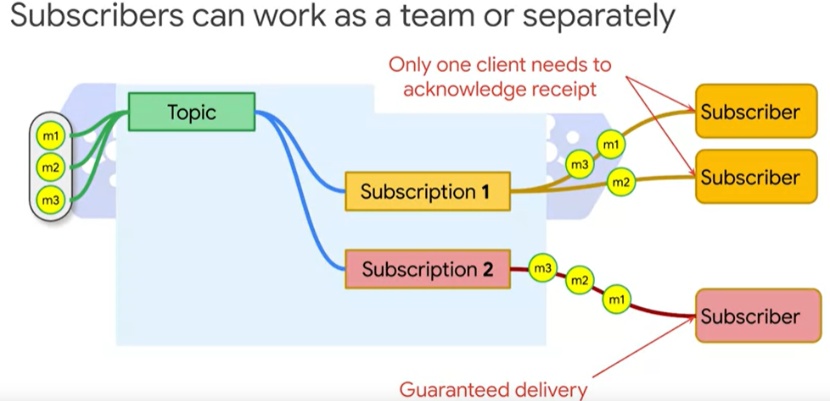

* For a push subscription, you only have one web endpoint, so your will only have one subscriber. Than endpoint could be an app or a cloud run container which autoscales
* The limit to publishing a message is 10mb, you can add meta data such as author, so that the subscriber can easily filter out those messages. So instead of serializing and deserializing, it will just keep track of those key-value pairs. This is show below

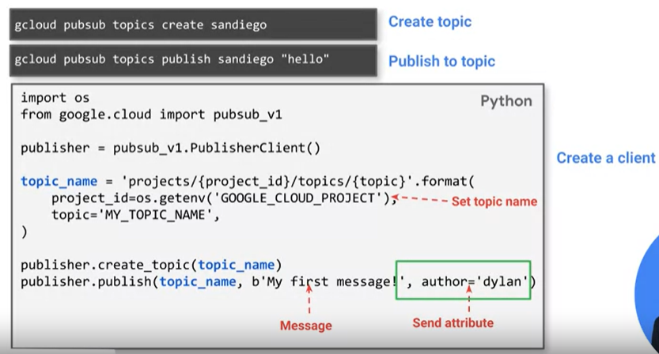

* Next we need to create a subscriber to pull the message, we can setup a synchronous/asynchronous pull shown below

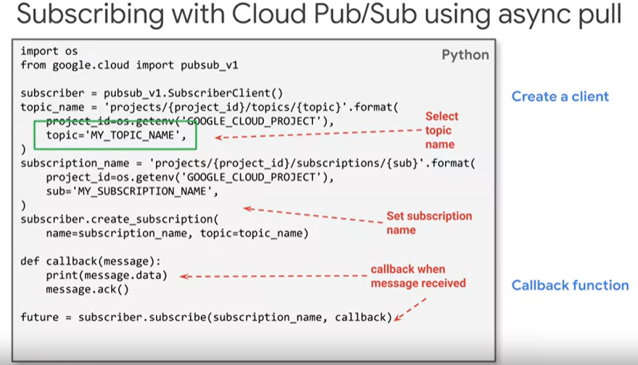

* Messages can be received in your application using a long-running message listener and acknowledge one message at a time shown in the example above. Define a callback for asynchronous pull
* Example of synchronous pull shown below

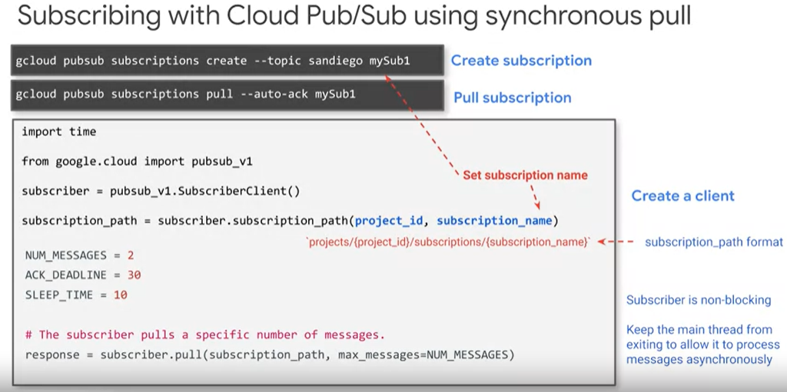

* When you need a precise cap on the number of messages retrieved by a client at any given time
* You can set a limit on how many messages you want to retrieve at a time. In the example above we are pull 2 messages at a time.
* Asynchronous pull is preferable for latency sensitive applications
* By default the publisher will batch publish messages, we can turn this off if we want lower latency.
* Batching publisher messages, allows the publisher to wait and send 50 or 100 messages at a time which is efficient
* Controlling the batch publisher settings in code is shown below

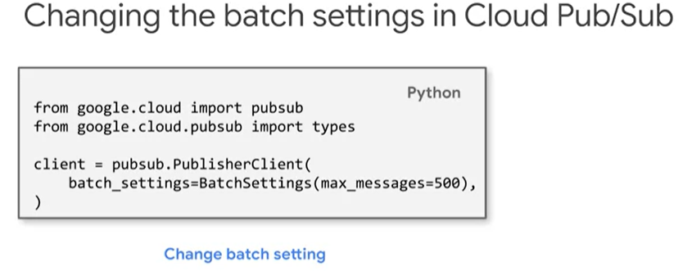

### Streaming into Big Query and Big Table

* When streaming data from Pub/Sub into Big Query through Cloud Data Flow, stream inserts into Big Query are 100k rows/sec
* You are charged for streaming inserts, but not for batch inserts. So use batch loading/repeated batch loading instead of streaming inserts into Big Query unless the application requires streaming inserts
* Inserting streaming data into Big Query code shown below

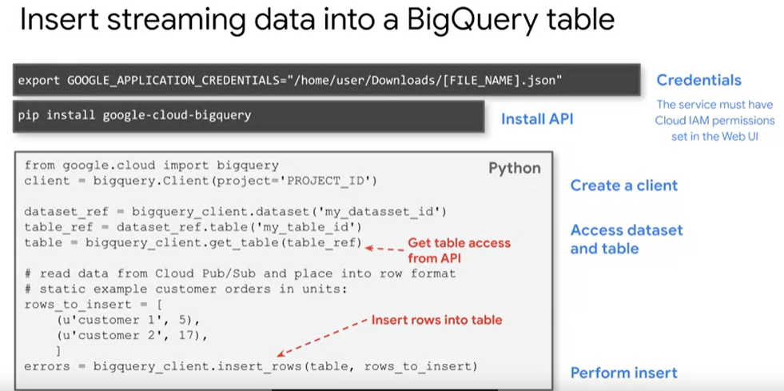

* And then we run sql queries in Big Query to view the results
* Next we can use Data Studio to visualize the results from the query
* Sometimes we will require streaming data to be present quicker(higher throughput), e.g. run the query and visualize the results. For this case you will find that Big Query will not be fast enough because it only writes at 100k rows/s, so for this instance we need a higher throughput so we will use Big Table

# 7. Big Table

* 100 000 queries/s with 10 Nodes at 6ms latency
* Ideal for non-structured key-value data where each value is typically no larger than 10mb
* Big Table is not good for highly structured data, transaction data, small data(less than 1 Terabyte) and anything requiring Sql Queries and Sql like joins
* Best used for big data above 300 gigabytes, has fast access but constantly used over time
* Collosus(where the data is stored in tablets(inside collosus)) has 3 replicas by default
* Organized lexicographically(alphabetical order) by the row key
* Abandon our design of Sql for Big Table
* Speed depends on your data and row key shown below

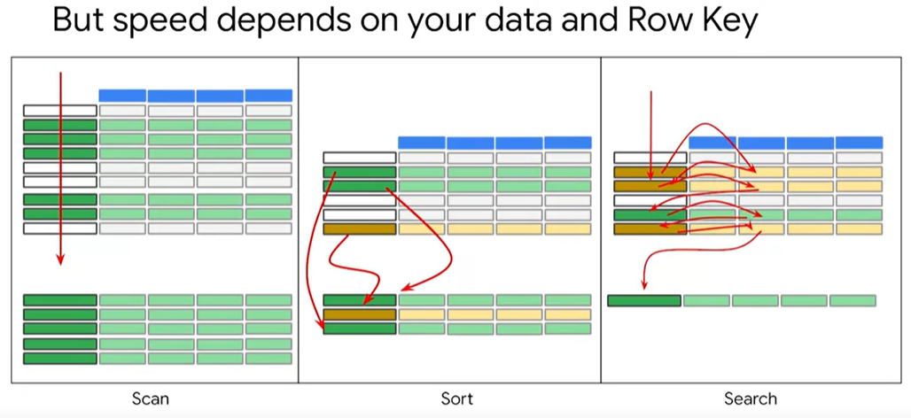

* The green values are our results which has keys
* If we are scanning the results, then it just scans the key and processes fast.
* If we are sorting, there is going to be overhead because if our data is massive, then it will have some overhead
* The third instance is searching, e.g. one of the columns contain critical data, you cannot tell whether a row is a member of a solution set or not without examining the data contained in the critical column. The row key is no longer sufficient. So to solve this problem. We can divide it up into multiple steps:
  + Once scan through the row keys and subsequent scans through the columns and then a final sort to get the data in the order that you want
* It becomes more complex when you have a criteria with a value in one column and a value in another column
* So the point is that when using Big Table, you need to get your data in order first if possible
* You need to construct a row key that minimizes sorting and searching and turns your most common queries into scans
* Big Table contains row keys and column families shown below

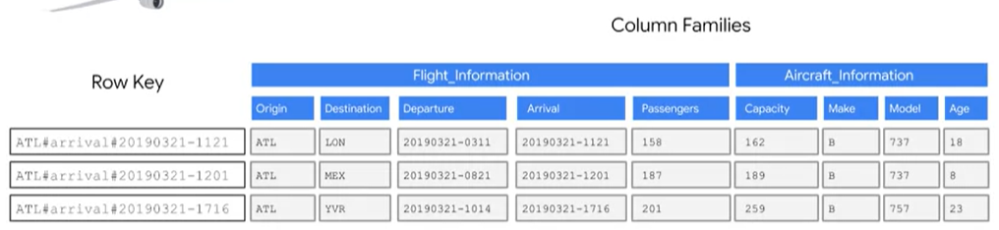

* By accessing the column family, you can pull some of the data you need without pulling all of the data from the row or having to search for it and assemble it
* Reverse Timestamps if it is the key, so it will be at the top of the table
* Performance decreases if there are too many column families, cloud big table handles 100 column families without losing performance
* There is no compression of data for Big Table
* Key Visualizer is used to visualize read/write access patterns over time and key space
* It has a heat map, the x-axis shows the time, the y-axis is the row keys, dark colour(slow), hot colours such as red(fast), white(fastest)

# Coursera Course

## Course 1

### Week 1

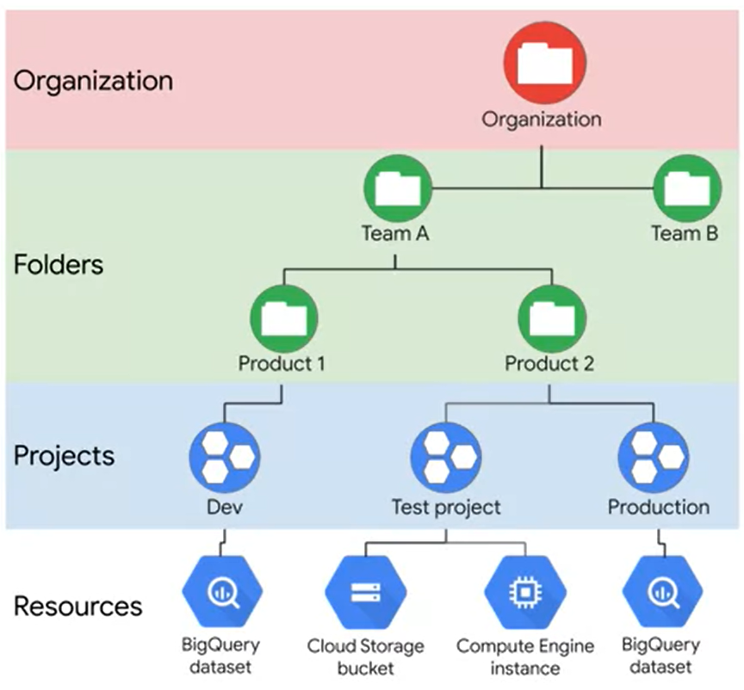

#### Notes

* Security, we only need to worry about the higher level access, because Google cloud takes care of the lower level security
* The cloud automatically encrypts data such as in Big Query which uses keys to encrypt the data.
* Compute:
  + Compute Engine: Single machine in which the user manages the instance
  + Google Kubernetes Engine (GKE): Cluster of machines which runs containers in which the user has packaged code into
  + App Engine – Allows you to run code without worrying about infrastructure, google will worry about provisioning resources. (PAAS)
  + Cloud Functions – Executes code in response to events, whether the event is once a day or many times each second. It is serverless. (FAAS)
* IAAS – Infrastructure as a Service
* PAAS – Platform as a Service
* FAAS – Functions as a Service

#### Reading Case Studies

When reading google cloud case studies we want to identify the following.

* The challenges that the company faced
* The solution to those challenges
* Finally what was the business impact after solving the challenge

**Practicals**

* First we have to create the Big Query Project/Dataset/Table, the first option is that we can use the Big Query UI, **goto Add Dataset, then select the bucket location, and specify a project name/Dataset Name, Table Name**. Next we add the table schema **Edit as Text**
* Another method is to use the command line
* For Cloud Dataflow, we streaming data from pub/sub to Big Query. We have to create a staging bucket first.
* Next in Dataflow we select **Create Job from Template -** Cloud Pub/Sub Topic to BigQuery template. We do this within a window.
* Next in details for **Cloud Pub/Sub input topic:** projects/pubsub-public-data/topics/taxirides-realtime
* Enter **Big Query output table:** <myprojectid>:taxirides.realtime, enter location for staging storage bucket that we created gs://<mybucket>/tmp/

## Course 2

### Data Lakes

* Where all the data is stored in an organization
* Considerations to make is that we need to pick a storage that supports all formats
* In Google Cloud we use Cloud Storage Bucket (Main), Cloud SQL, Cloud Big Table as our Data Lake, where all the data from Databases and other storage will be stored over here. Depends on what format of Data is, then we choose Cloud Storage, Cloud SQL, Big Table. Remember it is recommended that all data first get loaded into Cloud Storage as our staging area.
* Store Raw Data
* **Cleaned and Transformed Data is stored in a Data Warehouse for Analytics, such as cleaned data stored in Big Query**. You can store this in cloud storage, but for analytics place in Big Query
* This ensures high data quality
* In Big Query it is not under the storage section because it is cleaned transformed data, sometimes the **data is already in the right format**, then we will only need to **Extract and Load** using Big Query Connectors, so **WE WON’T HAVE TO USE CLOUD DATAFLOW TO TRANSFORM**
* We can have EL, ELT(Extract Load Transform) and ETL(Normal One)
* An example of ELT is where we Load the data into Big Query, and only transform it using a SQL query and write the result into another table.

### Data Governance

* One solution for data governance, is cloud **Data Catalog** and **Data Loss Preventions API**
* Data Catalog makes all the meta data available for the users to search
  + You group Datasets with Tags and flag certain columns as sensitive
  + Useful because for many different datasets that has many tables, users with different access levels can search easily through Data Catalog
* Data Loss API (DLP) is good for sensitive data such as credit card numbers etc. Just paste data and it will automatically detect sensitive data.

### Encryption

* **GMEK(Google Managed Encrypted Keys)** – All data in google cloud is encrypted at rest and in transit and there is no way to turn of the encryption. The encryption is done using encryption keys **GMEK**.
* There are 2 levels of encryption: **DEK** – First the data is encrypted using a key, then **KEK** – then the key of the data encryption is encrypted using another key
* The KEKs are automatically rotated on a schedule that uses the current KEK stored in Cloud **KMS**(Key Management Service). This is automatically managed, you don’t have to do anything
* You can also manage the encryption key yourself, if you don’t want google to manage it then you can call the creation and existence. This is done using **CMEK(Customer Encryption Keys)**
* You can also avoid **KMS** completely and supply your own encryption and rotation mechanism called **CSEK**
* The data encryption option that you choose depends on your business, legal and regulatory requirements
* The 4th encryption is client-side encryption – encrypting the data before it is uploaded and then you have to decrypt the data yourself before it’s used.
* You can also place a hold on the object/bucket/policy, and all the operations(delete, modify) on that object are suspended until that hold is released.
* Data locking such as the point above is different from encryption. Encryption prevents someone from understanding your data, locking prevents them from modifying your data.

**OLTP(Online Transaction Processing) such as Relational Databases are heavily focused on writes, OLAP systems are heavily focused on reads. We can perform EL(Extract Load) by exporting the database as a file and loading it into Big Query.** It is better to first load it into Google Cloud Storage as a stagining then load it into Big Query.

Can use Big Query to query the data stored in Google Cloud Storage without having to load the data into Big Query. This is called a federated query, query from an external data source using external connection.

**Optimizing Big Query with Partitioning and Clustering**

* Partition tables to reduce cost and amount of data
* If we **partition the table** by a date column, these rows partitioned by date will be stored in shards because Big Query will change its internal storage so that dates are stored in shards
* All of the data in a block belongs to a single partition
* This requires Big Query to hold more meta data then a non-partition table. As number of partitions increases, the amount of meta data overhead increases
* Each row of data below is a partition
* Partition can be set in 3 ways: Ingestion Time, any column that is of type date or timestamp, integer-typed column

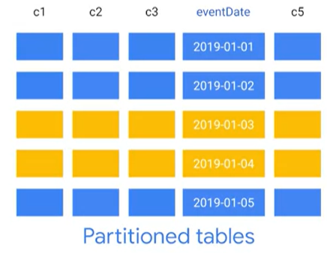

* Clustering improves the performance for certain types of queries such as queries that uses filter clauses and those that aggregate data because big query sorts the values in the clustering columns
* Once the data is written to a cluster table big query sorts the values in the clustering columns. userId is the clustering column below
* These values are used to organize the data into multiple blocks
* You setup clustering during table creation time
* Clustering is only supported if you table is partitioned

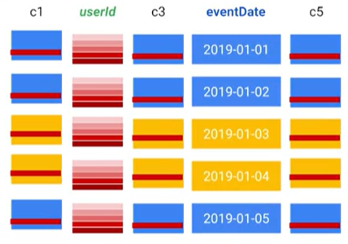

## Course 6 (Preparation for the Exam)

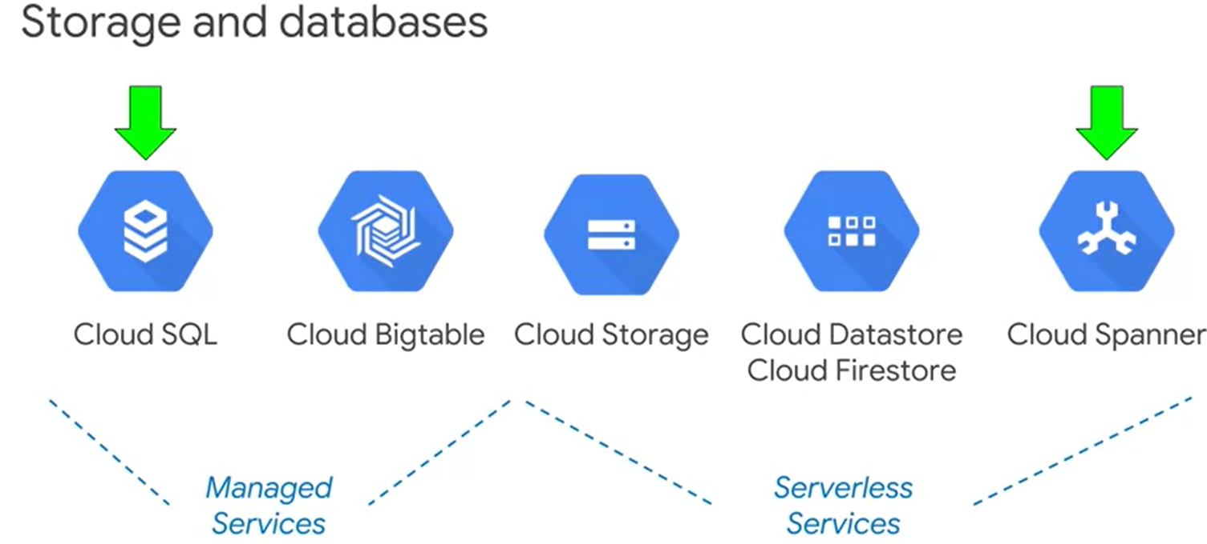

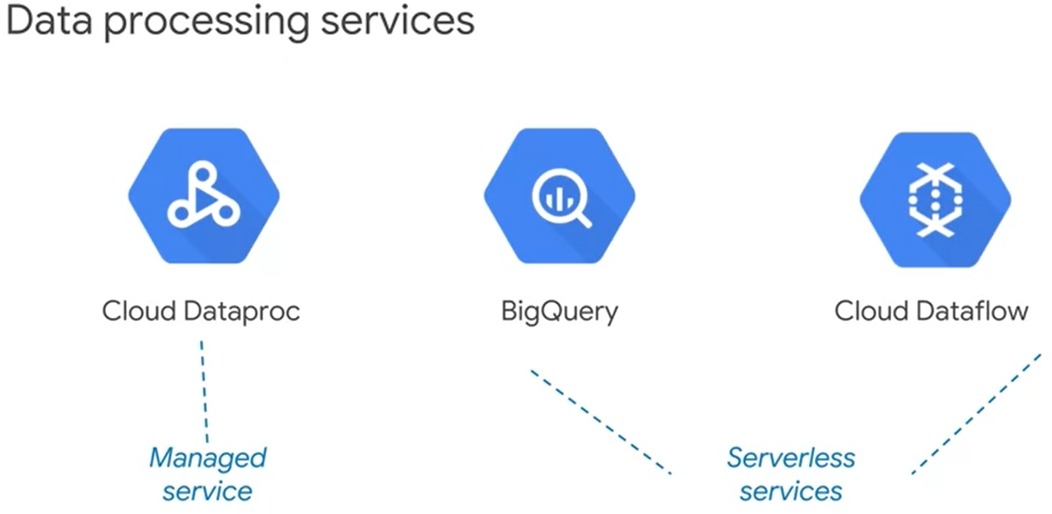

* In Cloud Dataproc, the **Data Abstraction** in Spark is resilient distributed dataset and the **Processing Abstraction** is a directed acyclic graph (DAG)
* Big Query, **Data Abstraction** is Table, **Processing Abstraction** is Query
* Cloud Dataflow, **Data Abstraction** is PCollection, **Processing Abstraction** is Pipeline

Think of a solution in terms of **Representation**, **Pipelining** and **Infrastructure**

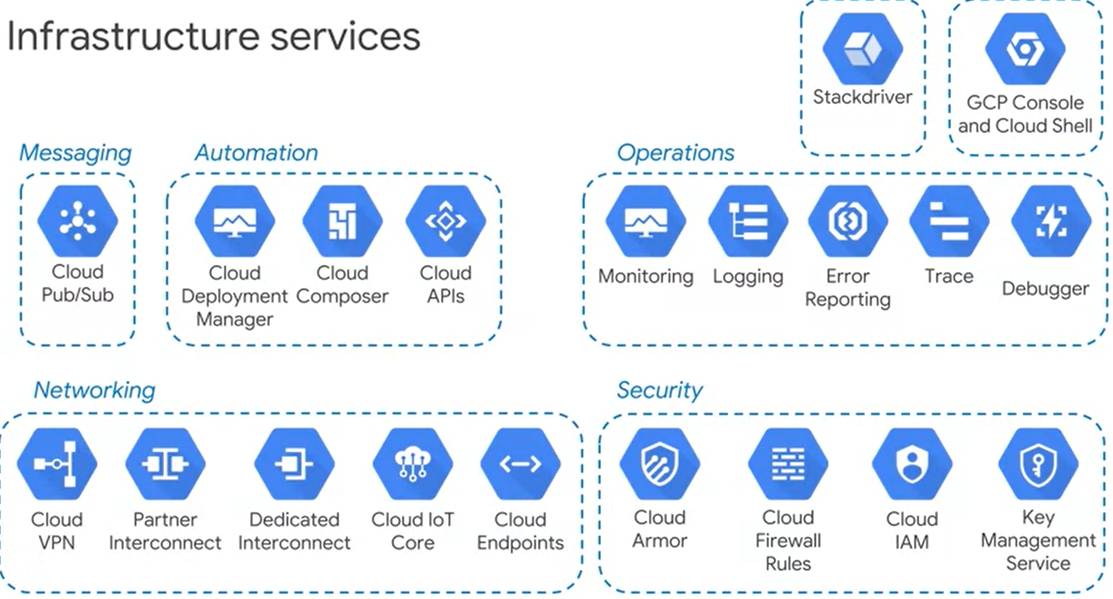

* Cloud VPN, Partner Interconnect play, Dedicated Interconnect play a role when on-premises data must be transmitted to services on the cloud.
* Cloud IAM, Firewall Rules and Key Management Services as well as stackdriver monitoring are important for **management and monitoring** especially in Financial institutions.

Now Looking at **Representation**:

* If data is stored on a file system, it is faster to retrieve that data by name
* Data stored on a database, data is easier to find by logic such as SQL
* If you store data in a processing system, it makes it easier and faster to transform the data instead of retrieving it.
* Networking transmits serial data as a stream of bits, zeros and ones
* Data is also stored as bits
* If you have a data object with a meaningful structure, you need some method to flatten and serialize the data first into zeros and ones, then it can be transmitted and stored
* When the serialized data is retrieved, we have to de-serialize it to recreate the object
* Structure is Avro(Apache Hadoop), JSON, XML, CSV etc.
* Data in Cloud Dataflow is represented in PCollections
* In Cloud Dataflow, each step is a transform
* A transformation and a collection of transforms make a **Pipeline**
* The pipeline is executed by a program called the runner
* So data is stored in PCollections, transforms happens on PCollections and return PCollections
* PCollections are immutable(cannot be modified) which is the secret for cloud dataflows speed
* With streaming data, you wouldn’t know for example when to take the average, so dataflow allows you to define a window, in which you could take the average or perform aggregations within that window
* Changing from Hadoop to Dataflow can be expensive and time consuming because rdd’s have to be converted to PCollections

Now looking at **Pipelining** i.e. Designing Data Pipelines

**Dataproc Pipelines**

* Spark does the pipeline in memory, which makes it quick
* Spark does not execute the pipeline until it sees an action
* Spark waits until it has all the information(all the requests are in), then it can decide how to distribute the work(applying resources) and run the pipeline
* The process of waiting on transforms and executing on actions is called lazy execution
* Sparks input into a transform is RDD and output is RDD
* When spark sees a transform it registers it in the graph(DAG) and waits
* An action triggers spark to process the pipeline
* The output after the spark job is a text file rather than a RDD
* When the system tries to process the data as soon as it is received, is called eager execution
* Tensorflow uses both eager and lazy execution
* Sometimes it is hard to do analysis in Big Query using SQL, so it is better to extract the data from Big Query and let Spark do the analysis and write it back out to another dataset in Big Query
* Use initializations scripts to load, install and customize software

**Dataflow Pipelines**

* Users use roles to limit access to only dataflow resources not just the project
* Pipelining scripts can be written in Java/Python and executed using Apache Beam
* Dataflow templates open up new options for separation of work which results in better security and accountability

Now looking at **Infrastructure**

**Big Query**

* Access control level is at the project and dataset level
* Has connectors to Cloud Storage(mainly connectors for csv files), Cloud Bigtable, Google Sheets

**Designing Data Processing Infrastructure**

* Think of Data ingestion as **Volume(How Much), Velocity(How Often), Variety(How Consistent)**
* Use **gsutil** for upload files
* Use **Storage Transfer Service** when data is in another location such as another cloud
* Use **Transfer Appliance** when data is too big to transfer electronically

### Building Data Processing Systems (Prev Sect. was Designing Data Processing Systems)

**Transaction Qualities**

* ACID – Atomicity, Consistency, Isolation, Durability
* BASE – Basically Available, Soft State, Eventual consistency
* Eventual Consistency can be turned into strong consistency by reading entity, value and indexes like in the Datastore e.g. First is the lookup by key method and Second the ancestor query

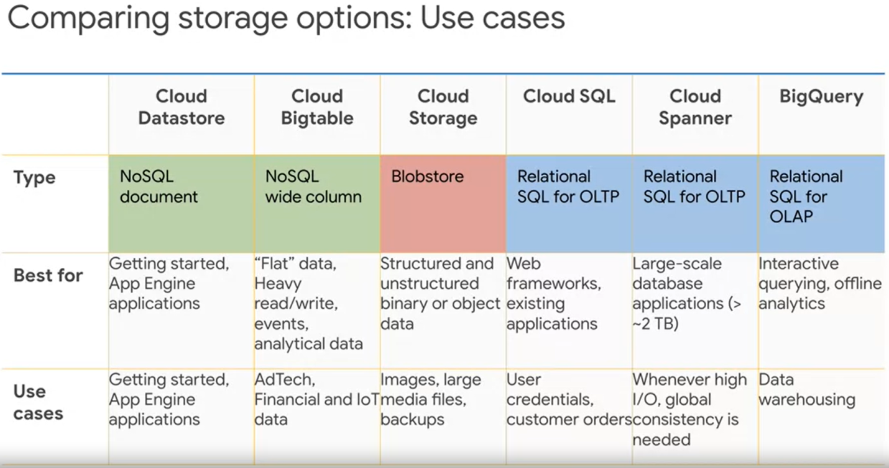

* Why use Big Table over Cloud Spanner? Because Big Table has 100 000 queries/second @6ms for a 10 node cluster. For cloud spanner this would cost more since it will use 150 nodes

SQL QUERIES

* Order of queries: **Select**, **Name**, (**Count, Sum, Avg, Min, Max**) as val, **Extract**(Day/Week/Month from date_column) as val, **From**, **Where**, **Group By**, **HAVING COUNT(ID) > 10**, **Order By** name_col ASC/DESC
* Can Group By multiple column names
* Having is an if condition to check if specific group meets criteria, basically a condition on the aggregate function
* CTE (Common Table Expression can only be used **once** within a query and cannot be called outside a query)

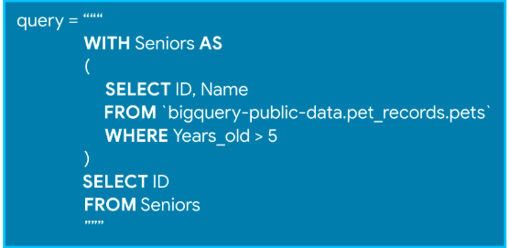

### Analyzing and Modeling

* 3 Modes of NLP API:
  + Sentiment Analysis
  + Entities
  + Syntax
* Pretrained Models API

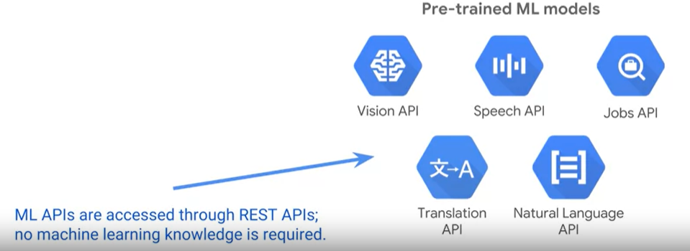

* If pre-trained models don’t work for you, then build custom models

### Policies

* A policy is set on a resource
* Each policy contains a set of Roles and Role Members
* Resources Inherit policies from parents
* So a policy can be set on a resource such as a service and another policy can be set on a parent such as a project that contains that service
* The final policy is the union of the parent policy and the resource policy
* If there is conflict between the parent and resource policy, which one take precedence?
* If a parent policy overrides a more restrictive resource policy, the project policy wins
* It is better to assign roles to groups and use group membership to grant permissions to individuals

### Steps for creating Deeplearning Model in AI Platform

* Build a prototype Estimator with sample data specify the input file to read from
* For submitting a job to AI Platform, make all the parameters passable by changing the hard coded hyper parameters to configurable parameters using arg.parser.
* Making it configurable sets you up for hyper parameter tuning
* For serving the model we can’t use the standard input function, because requests will come in json format, so have to change input function if it is just prediction, use if statement to swap over if prediction.
* Next specify for deployment where our trained model location is:
* Then we run the following to deploy:

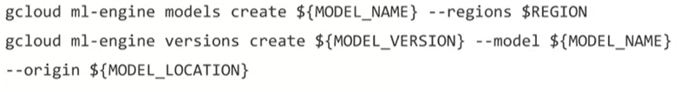

* So the client code will now be able to make REST API calls to our deployed model endpoint.
* **Real Time Prediction – In real time we can have streaming data entering from cloud Pub/Sub, this is processed by cloud dataflow, next since we have already deployed our model on AI Platform and have an endpoint, we can get Cloud Dataflow send requests to the deployed model using the data it has transformed coming in from Pub/Sub**
* Every now and then we can retrain the model in big query and deploy the new model which gets swapped out with the old model. The entire process is shown in the diagram below.

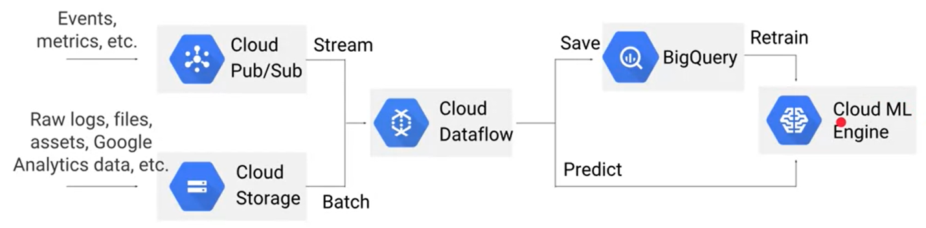

# EXAM QUSESTIONS